**SBA Evaluation Solution**

1. **Business Requirement**

"To disable a Course for certain number of days"

When a course is disabled, it will not be shown in Search results. After passing of specified number of days, Course can start appearing in search results.

1. **Front-End(Angular) Solution**
   1. Add the status **DISABLED** in .ts file **training.component.ts** to update the **trainingStatusList** and declare **enableDate** to get the new inputted enable date as below:

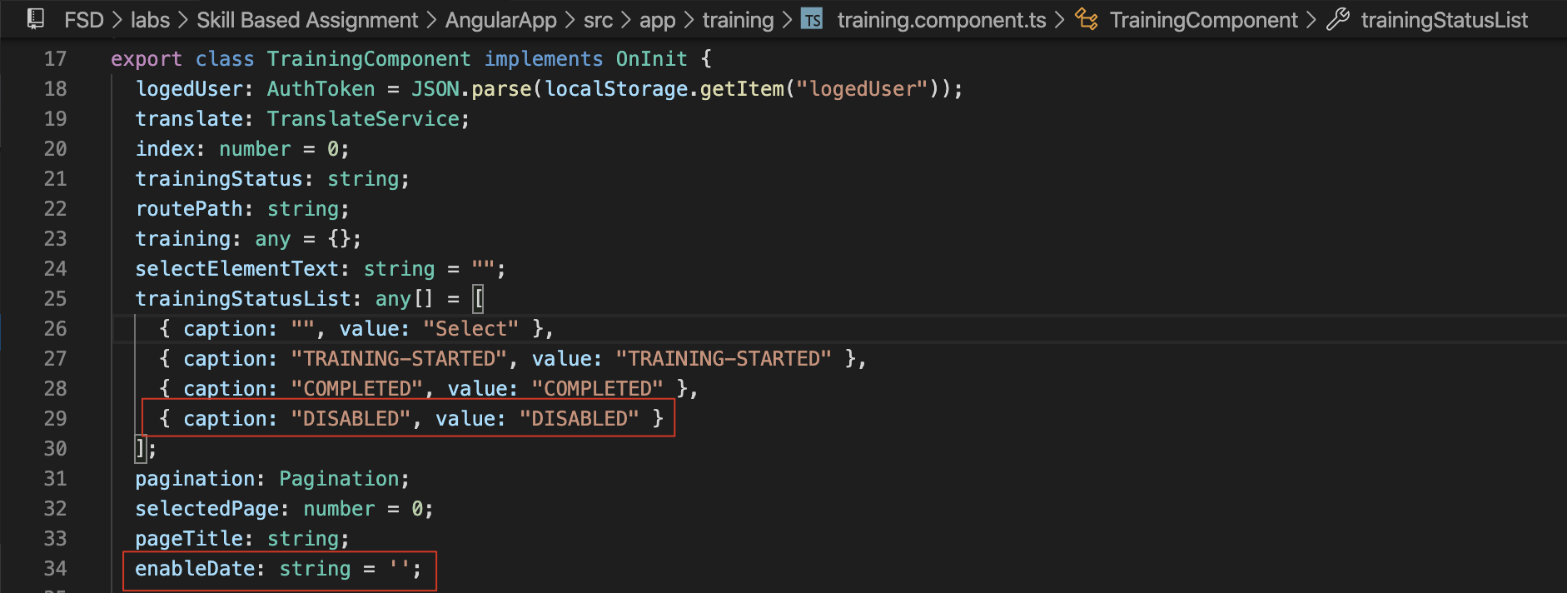

And add **ngAfterViewChecked()** to enable calendar selection window for the new property enableDate:

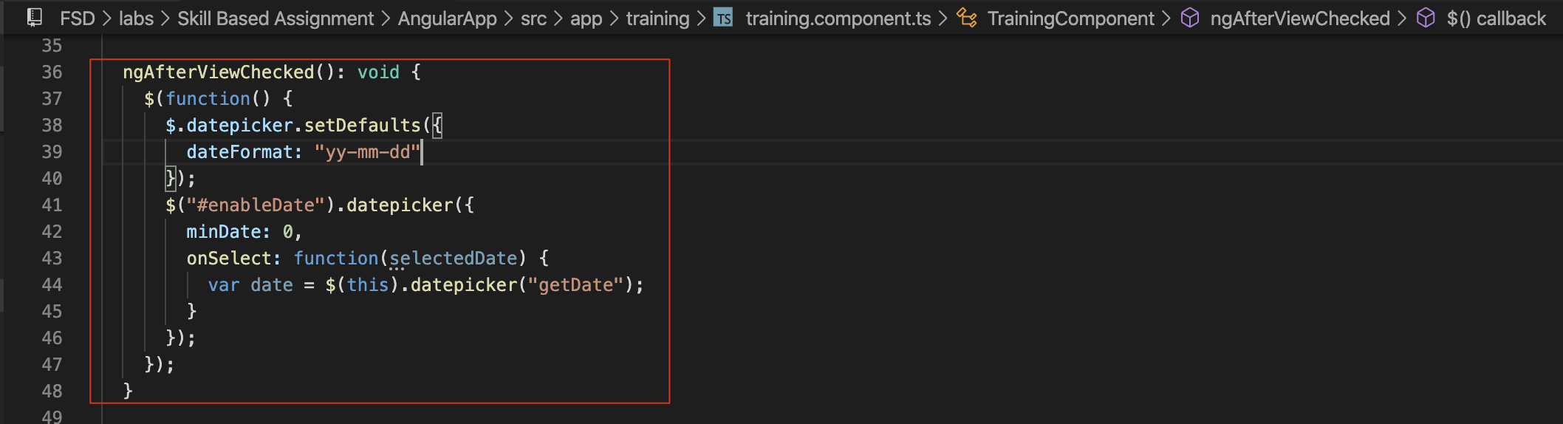

* 1. Add a new property **enableDate** in **training.ts** model:

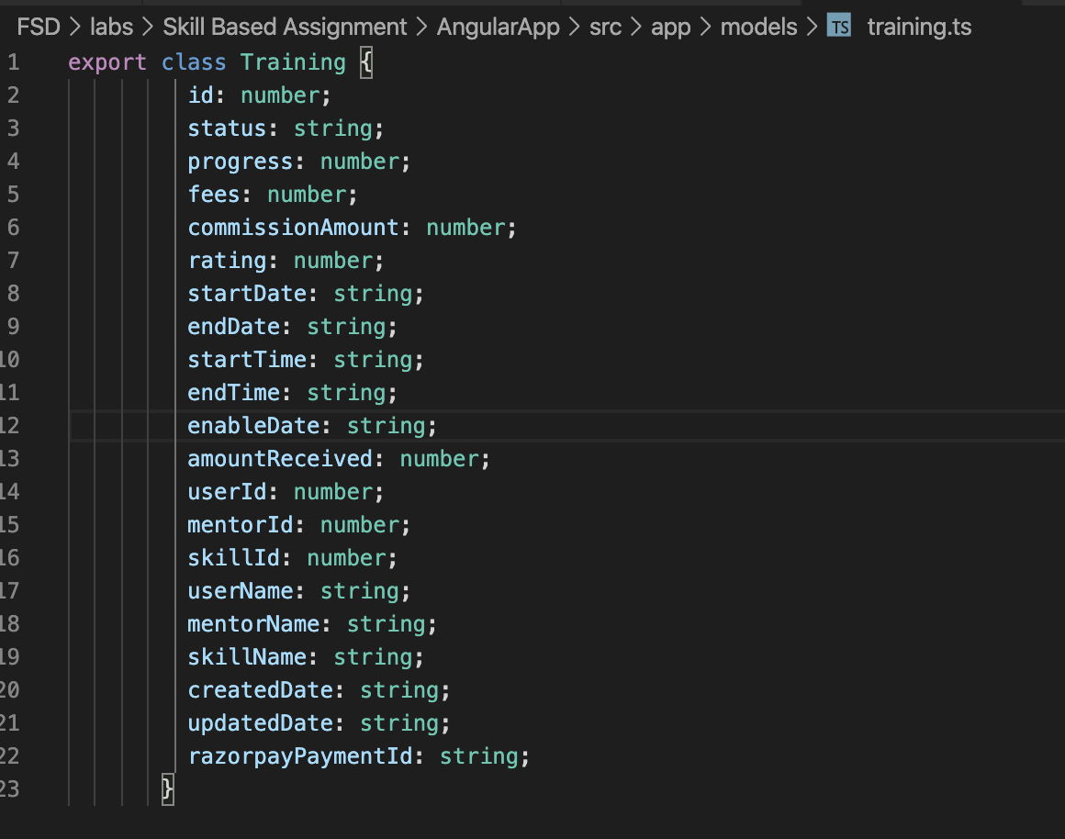

* 1. Update **training.component.html:** add a new column to update enable date:

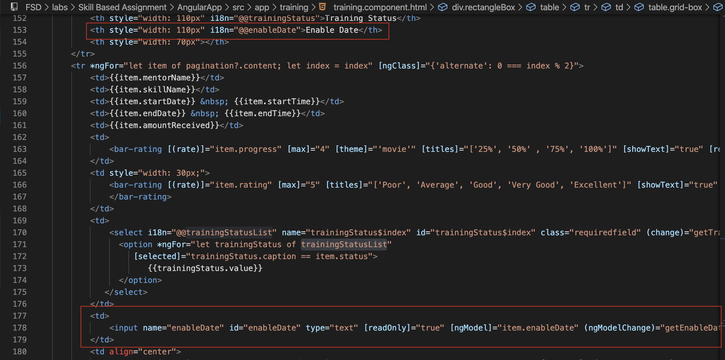

* 1. Update the **training** entity with new property enableDate in **training.component.ts** when updating training status:

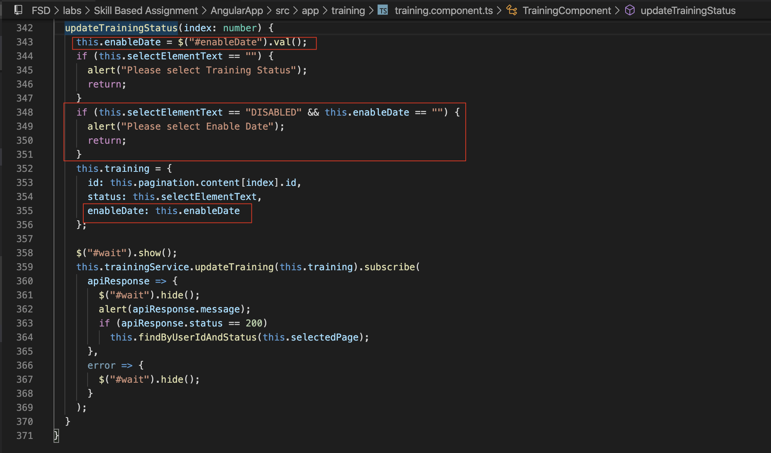

1. **Back-End(Microservice) for Update Training Status with DISBLED status Solution**
   1. Update the **training** entity:

* 1. Update **TrainingDtls** model:

* 1. Update **TrainingStatus enum** with DISABLED status in **cmmon-security-service Constant class**:

1. **Batch Job for enable the disabled training records when reach the setting enable date solution**
   1. Add a method **findToBeEnabledTrainings** to get all the target disabled trainings (enabled date <= today) in **trainingRepository** interface:

* 1. Add a method **findToBeEnabledTrainings** for cron batch job calling in **TrainingService** class:



* 1. Also, add a method **updateTrainingToEnable** for updating the disabled training to be enabled and remove the inputted enableDate:

* 1. Add a scheduled function **updateTrainingToEnable** for running the batch job with cron in **ScheduledJobs** class:

* 1. Setup the **cron job schedule**:

For the testing as above, it means the job will be executed **every 1 minute from 9:00am to 5:00pm on 12th each month**. Actually we can schedule the cron job running one time every day: **0 15 1 * * ?**, the cron job will be executed at **1:15am every day**.

1. **Step by step for disable training record**
   1. Check the training status in mongo db firstly:

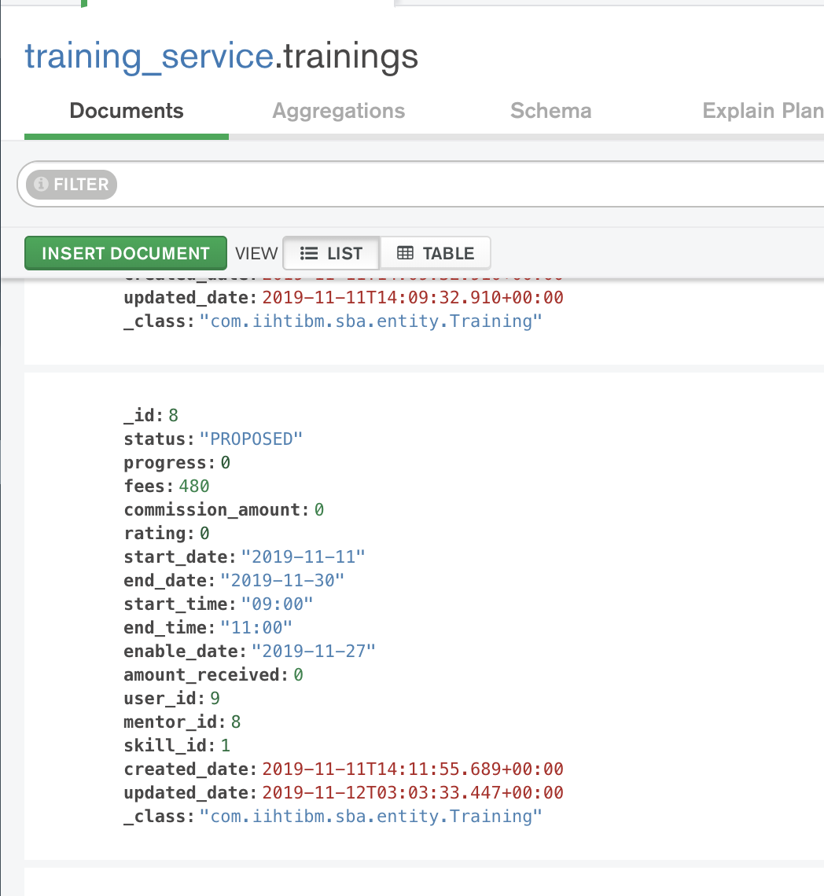

* 1. Go to the update training record UI, set the status to be DISABLED and set the enable date:

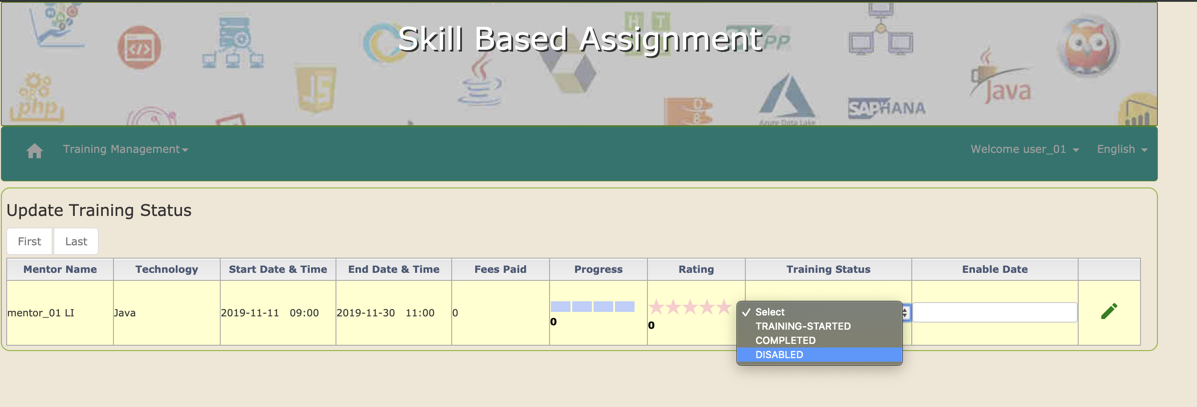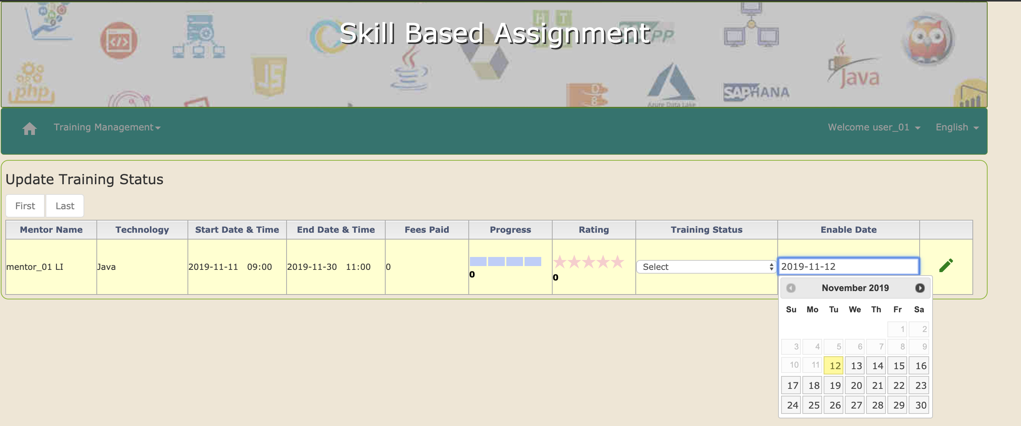

* 1. Update the training status successfully:

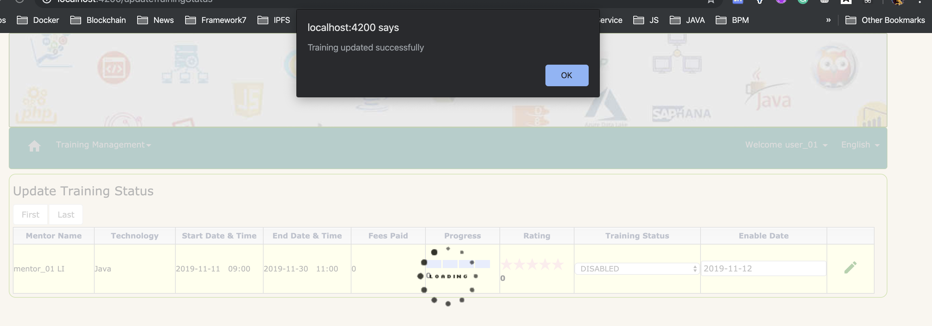

* 1. Check the training in mongo db again, the status has been updated to DISBLED and the enable date has been updated also:

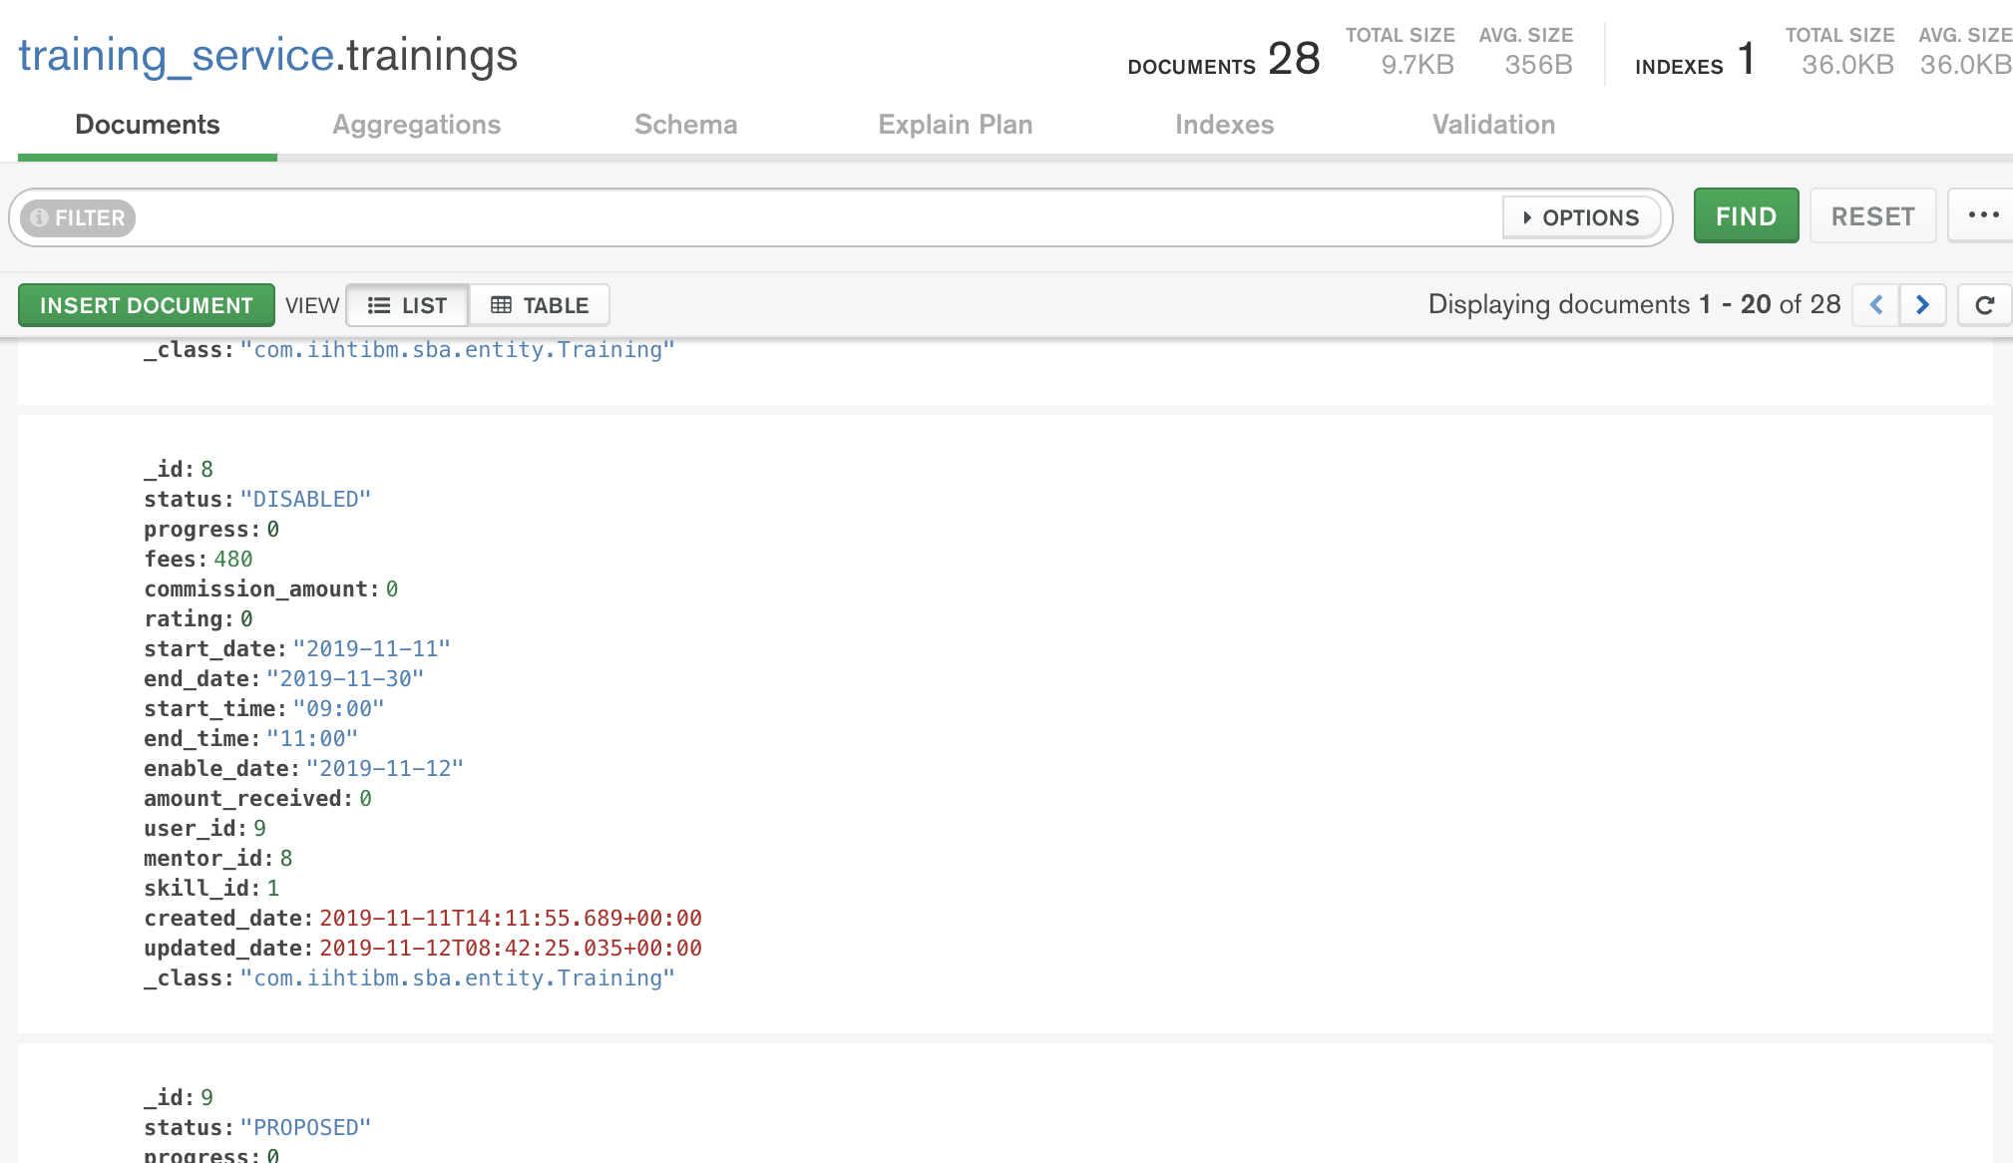

* 1. The disabled training will NOT be shown in the search result:

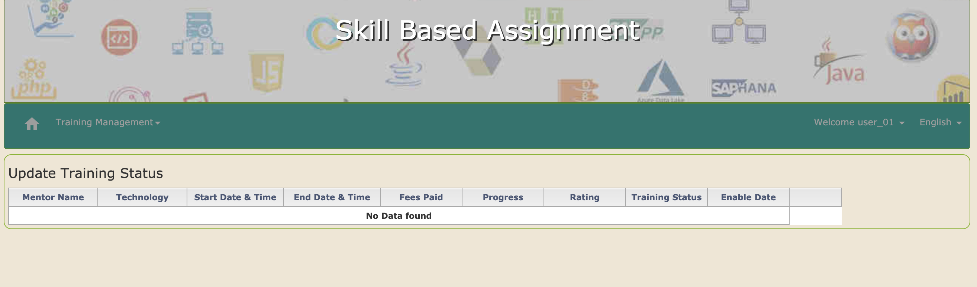

* 1. The scheduled cron job running, find 1 disabled training record with the enabled date <= today:

 And can NOT find the target disabled training record with the enabled date <= today when the scheduled cron job running again:

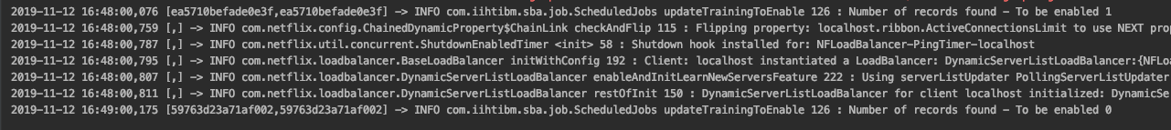

* 1. Check the training record in mongo db, it has been enabled again:

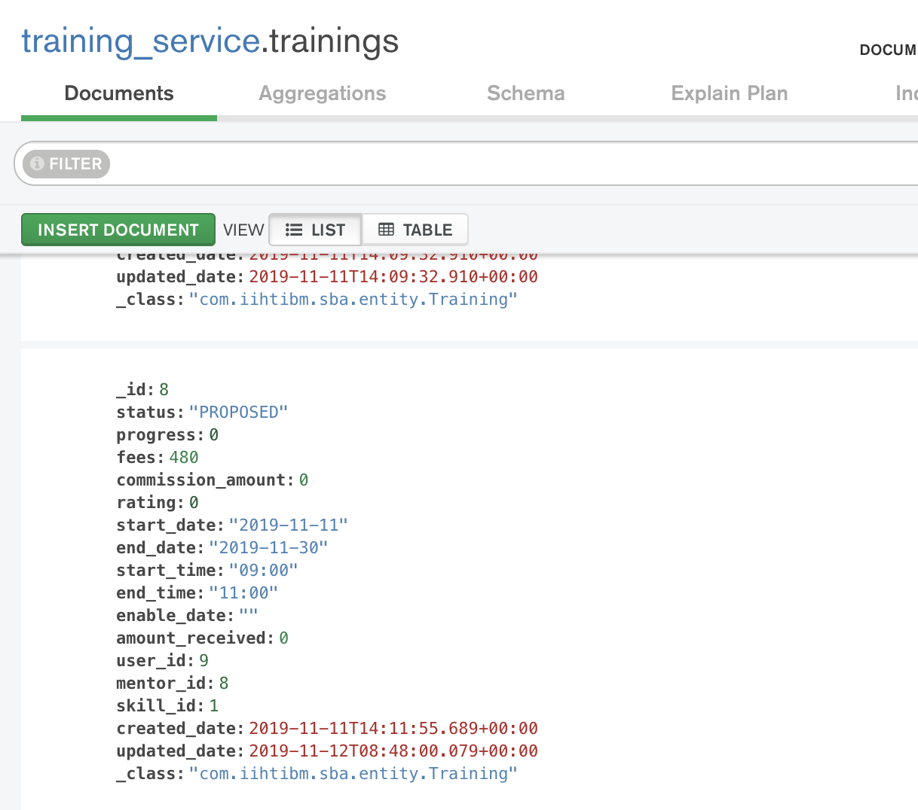

* 1. Also the training will be shown again in the search result:

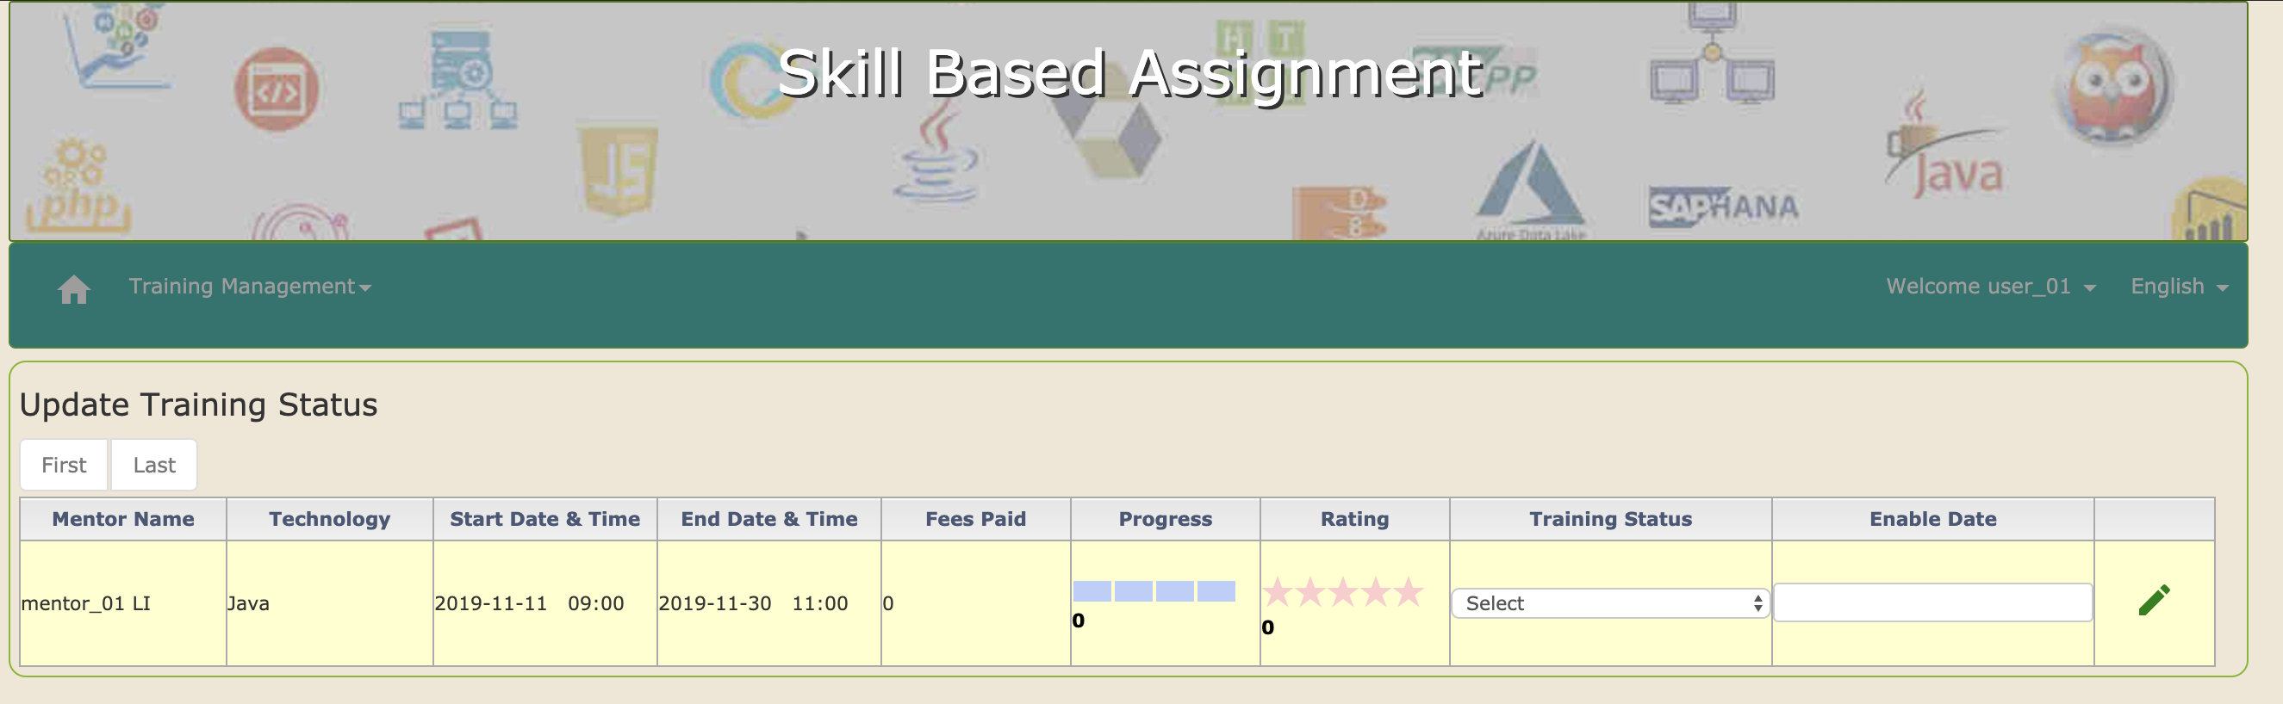

1. **Github URLs**

<https://github.com/lqsavage/sba-angularapp.git>

<https://github.com/lqsavage/sba-training-service.git>

<https://github.com/lqsavage/sba-cmmon-security-service.git>